

SYMBIOSIS INSTITUTE OF TECHNOLOGY
Department of Electronics & Telecommunication Engineering

MINI PROJECT REPORT
Analysis on Student Daily Commute
Exploratory Data Analysis using Python

Subject | Exploratory Data Analysis
Semester | Semester 2 – B.Tech (2025-2029)
Batch | EnTC A-3
Group | Group 1
Student 1 | Tanmay Agarwal | PRN: 25070123158
Student 2 | Tannishtha Gupta | PRN: 25070123049
Academic Year | 2025 – 2026
Date | 15th March 2026

Submitted to: Mrs. Snehal Bhosale (Faculty Incharge)
Department of Electronics & Telecommunication Engineering
Symbiosis Institute of Technology, Pune

DECLARATION

We hereby declare that the mini project report titled "Analysis on Student Daily Commute" submitted in partial fulfilment of the requirements for the subject Exploratory Data Analysis (Semester 2, B.Tech – EnTC A-3) is our original work.

The analysis, findings, visualizations, and conclusions presented in this report are based on our own study of the dataset and application of EDA techniques as taught in the course. We have not copied or reproduced any part of another person's work without due acknowledgement.

Tanmay Agarwal  PRN: 25070123158  EnTC A-3 | Group 1 | Tannishtha Gupta  PRN: 25070123049  EnTC A-3 | Group 1

ACKNOWLEDGEMENT

We are deeply grateful to our EDA faculty, Mrs. Snehal Bhosale, for her continuous guidance, encouragement, and invaluable feedback throughout the completion of this mini project. Her insights and suggestions greatly enriched the quality and depth of this report.

We also wish to express our sincere gratitude to the college administration at Symbiosis Institute of Technology, Pune, for providing us with the resources, infrastructure, and academic environment necessary for the completion of this project.

We are thankful to all our friends and students who helped us gather information and filled our google forms for surveys used in our Project Analysis- Student Commute Data Analysis.

We also acknowledge the open-source Python community and the documentation of libraries such as Pandas, NumPy, Matplotlib, and Seaborn, which served as essential references and learning resources throughout this project.

ABSTRACT

Daily commuting is a significant aspect of student life that directly impacts academic productivity, personal well-being, and time management. This report presents an Exploratory Data Analysis (EDA) of student daily commute patterns, conducted as a Semester 2 B.Tech Mini Project under the subject of Exploratory Data Analysis. The dataset, comprising 724 student responses across Pune city, was analysed using Python and its data science libraries — Pandas, NumPy, Matplotlib, and Seaborn. The study investigates travel time, one-way commute cost, primary and secondary modes of transport, peak travel hours, major bottlenecks, and overall satisfaction levels. Key findings reveal that Metro is the most frequently used and most cost-efficient mode of transport, averaging only Rs. 23 per trip. Cab services (Ola/Uber) emerged as the most expensive option at Rs. 298 on average. The average one-way commute takes approximately 57 minutes, with PMPML City Bus recording the highest average travel time of 81 minutes. The most frequently reported bottleneck was Waiting for Bus/Metro with 133 reported cases. This report documents the complete EDA methodology applied step by step — from data loading and inspection to descriptive statistics, missing value handling, frequency counts, cross tabulations, groupby analysis, and visualizations.

Keywords: Exploratory Data Analysis, Student Commute, Pune, Python, Pandas, Transport Modes, Data Visualization

1. Introduction

1.1 Background
Transportation and commuting form an integral part of urban student life. Students in metropolitan cities like Pune are required to navigate complex transport networks daily — often juggling multiple modes of transport, significant distances, and unpredictable delays. Understanding these patterns is not only relevant for urban planning but also for assessing the daily challenges faced by the student community.
Exploratory Data Analysis (EDA) is a fundamental approach in data science that enables analysts to understand the structure, patterns, and anomalies in a dataset before any formal modelling. In this project, we apply EDA techniques to real-world student commute data to uncover meaningful insights about how students in Pune travel every day.

1.2 Motivation
As B.Tech students ourselves, we are deeply familiar with the daily commute challenge. The idea of studying this problem using data-driven methods felt both personally relevant and academically significant. By collecting real data and applying the EDA techniques taught in our course, we aimed to produce insights that go beyond classroom examples — grounded in actual student experiences.

1.3 Objectives
The primary objectives of this project are:
- To apply EDA techniques taught in Semester 2 on a real-world dataset
- To understand the commute patterns, costs, and travel times of students across Pune
- To identify the most and least efficient modes of transport
- To uncover the major bottlenecks and delay points on student commute routes
- To analyse student satisfaction with their daily commute
- To present all findings through clear and well-labelled data visualizations

1.4 Scope
This project focuses on one-way commute data from 724 students travelling across seven major starting points (Kothrud, Baner, Pashan, Wakad, Shivajinagar, SIT Lavale Campus, and Other areas) to six key destinations in Pune. The analysis is limited to the data collected and does not involve predictive modelling or machine learning.

2. Dataset Description

2.1 Data Collection
The dataset was collected through a structured survey shared among students. Responses were gathered between March 7 and March 14, 2026. A total of 724 unique responses were recorded across a wide range of commute scenarios in Pune city.

2.2 Dataset Overview

# | Column Name | Data Type | Description
1 | Timestamp | String | Date and time the response was submitted
2 | Starting_Point | String | Area from which the student commutes
3 | Destination | String | Destination area of the commute
4 | Primary_Mode | String | Main mode of transport used
5 | Secondary_Mode | String | Secondary mode (for multi-leg journeys)
6 | Time_of_Day | String | Time slot of usual commute
7 | Travel_Time_min | Integer | Total one-way travel time in minutes
8 | One_Way_Cost_INR | Integer | Total one-way commute cost in Rupees
9 | Delay_Points | String | Major bottleneck on the route (132 NaN filled)
10 | Satisfaction | Integer | Overall satisfaction score — 1 (Low) to 5 (High)

2.3 Dataset Statistics at a Glance

Parameter | Value
Total Records | 724
Total Features (Columns) | 10
Numerical Columns | 3 (Travel_Time_min, One_Way_Cost_INR, Satisfaction)
Categorical Columns | 7 (Timestamp, Starting_Point, Destination, etc.)
Missing Values | 132 (only in Delay_Points column)
Unique Starting Points | 7
Unique Destinations | 6
Unique Primary Modes | 6
Time Period of Data | March 7, 2026 – March 14, 2026

3. Methodology
The project follows a structured EDA pipeline, applying each technique taught during the course in a logical sequence. All analysis was performed in a Jupyter Notebook using Python 3.

Step | Technique | Description & Python Methods Used
1 | Data Loading & Inspection | pd.read_csv(), df.shape, df.head(), df.tail(), df.info(), df.dtypes, df.columns
2 | Descriptive Statistics | df.describe(), .mean(), .median(), .std(), .min(), .max()
3 | Missing Value Analysis | df.isnull().sum(), isnull percentage, df.fillna('None')
4 | Frequency Count | df['col'].value_counts() on all categorical columns
5 | Unique Values | df['col'].unique(), df.nunique()
6 | Percentage Distribution | value_counts(normalize=True) * 100 across all key columns
7 | Filtering Data | Boolean indexing — df[df['col'] == 'value'], df[df['col'] > threshold]
8 | Cross Tabulation | pd.crosstab() — 5 different category-pair combinations
9 | Groupby Analysis | df.groupby('col')[['col2','col3']].mean() / .count() / .max()
10 | Sorting | df.sort_values('col', ascending=True/False).head(10)
11 | Derived Column | df.apply() with custom function to create Commute_Category column
12 | Visualizations | matplotlib bar chart, pie/donut chart, histograms, horizontal bar charts

3.1 Tools and Libraries
- Python 3.x — Core programming language
- Pandas — Data loading, manipulation, and all EDA operations
- NumPy — Numerical computations
- Matplotlib — Chart and plot generation
- Seaborn — Statistical visualizations
- Jupyter Notebook — Interactive development and presentation environment
- Google Colab — Cloud-based execution platform

4. Analysis and Results

4.1 Descriptive Statistics
The df.describe() function provided a statistical summary of all numerical columns. The key findings are as follows:

Statistic | Travel Time (min) | One-Way Cost (Rs.)
Mean | 57.47 min | Rs. 127.00
Median | 54.00 min | Rs. 65.50
Std Dev | 22.03 min | Rs. 126.11
Min | 20 min | Rs. 10
Max | 119 min | Rs. 445
25th %ile | 40 min | Rs. 33
75th %ile | 72 min | Rs. 210

The significant difference between the mean (Rs. 127) and median (Rs. 65.50) of commute cost indicates a right-skewed distribution — a small number of students paying very high cab fares are pulling the average up considerably.

4.2 Mode of Transport Analysis
Six primary modes of transport were used by students. The distribution is remarkably even, with Metro being the most popular at 18.09% and Personal Two-Wheeler the least at 13.54%.

Mode of Transport | Count | Share (%) | Avg Cost (Rs.)
Metro | 131 | 18.09% | 23
Carpool | 130 | 17.96% | 69
PMPML City Bus | 129 | 17.82% | 33
Cab (Ola/Uber) | 121 | 16.71% | 298
Auto Rickshaw | 115 | 15.88% | 286
Personal Two-Wheeler | 98 | 13.54% | 68

[Chart: Figure 1: Frequency of Primary Mode of Transport]

4.3 Travel Time and Cost Distribution
The histograms for travel time and cost reveal important distributional characteristics:
- Travel time is approximately normally distributed, with a slight right skew. The mean (57.47 min) is close to the median (54 min), suggesting a relatively symmetric spread.
- The cost distribution is heavily right-skewed. Most students spend under Rs. 100 per trip, but a long right tail extends to Rs. 445 (cab users), pulling the mean well above the median.
- PMPML City Bus has the highest average travel time (81.47 min) but one of the lowest costs (Rs. 33 avg), making it the most economical but slowest mode.
- Metro has the lowest average travel time (38.68 min) AND the lowest cost (Rs. 23), making it clearly the best value-for-money mode.

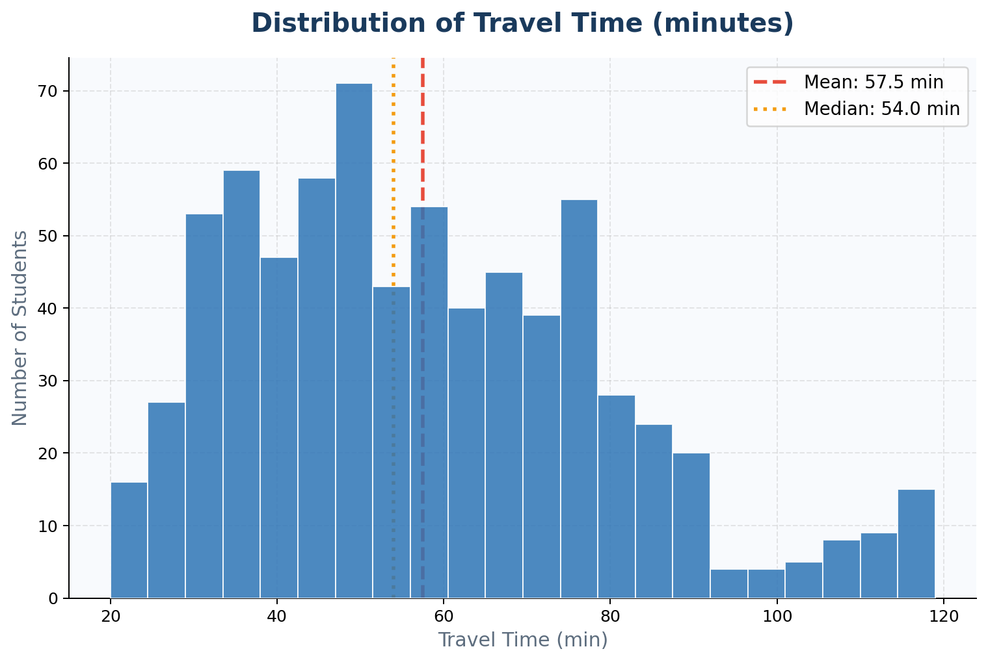
[Chart: Figure 1: Distribution of Travel Time (minutes)]
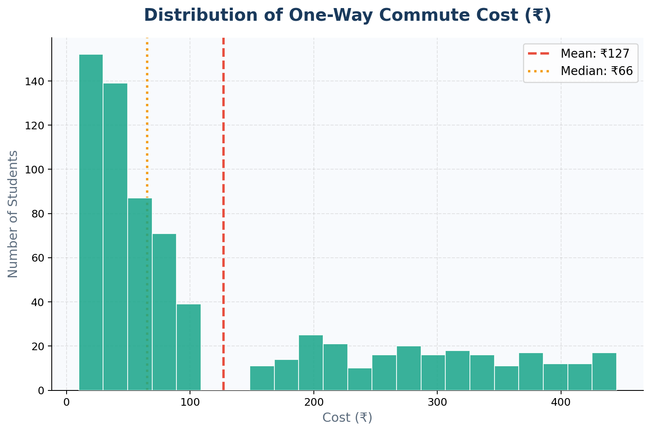
[Chart: Figure 2: Distribution of One-Way Commute Cost (Rs.)]

4.4 Time of Day Analysis
The commute data was distributed across four time slots. Midday (11 AM – 4 PM) saw the highest number of commutes (205, 28.31%), followed closely by Night (177, 24.45%), Morning Peak (174, 24.03%), and Evening Peak (168, 23.20%). The near-even distribution suggests that student travel is spread throughout the day rather than being concentrated in traditional rush hours.
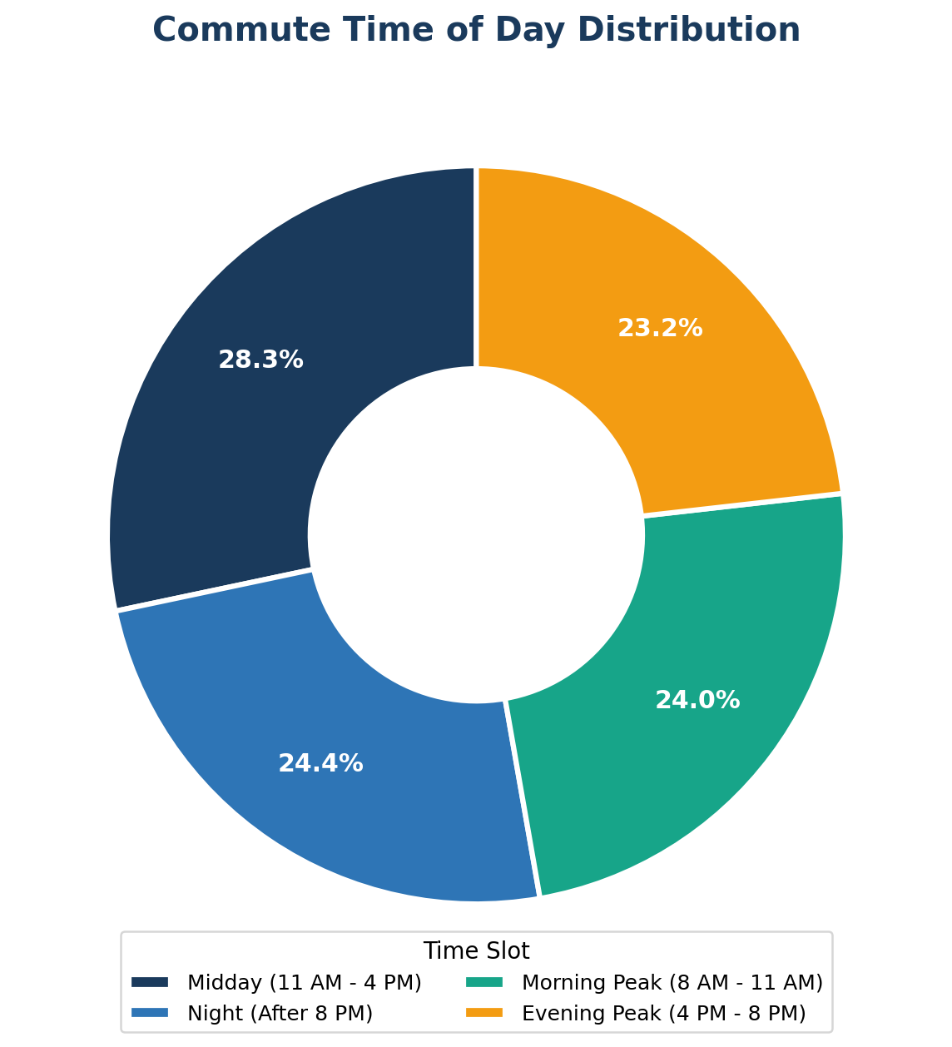
[Chart: Figure 3: Commute Time of Day Distribution]

4.5 Delay Points and Bottlenecks
Five major bottlenecks were identified in the dataset. A total of 132 records had no delay point (filled as 'None' during data cleaning). Among the reported delays:
- Waiting for Bus/Metro — 133 cases (18.37%) | Most common delay
- Hinjewadi Traffic — 127 cases (17.54%)
- Yerawada / Kalyani Nagar Junction — 114 cases (15.75%)
- Chandni Chowk — 110 cases (15.19%)
- University Circle — 108 cases (14.92%)

The dominance of 'Waiting for Bus/Metro' as the top bottleneck directly aligns with the high usage of public transport (Metro and PMPML) in the dataset. This suggests that service frequency and wait times are the most significant pain point for student commuters.

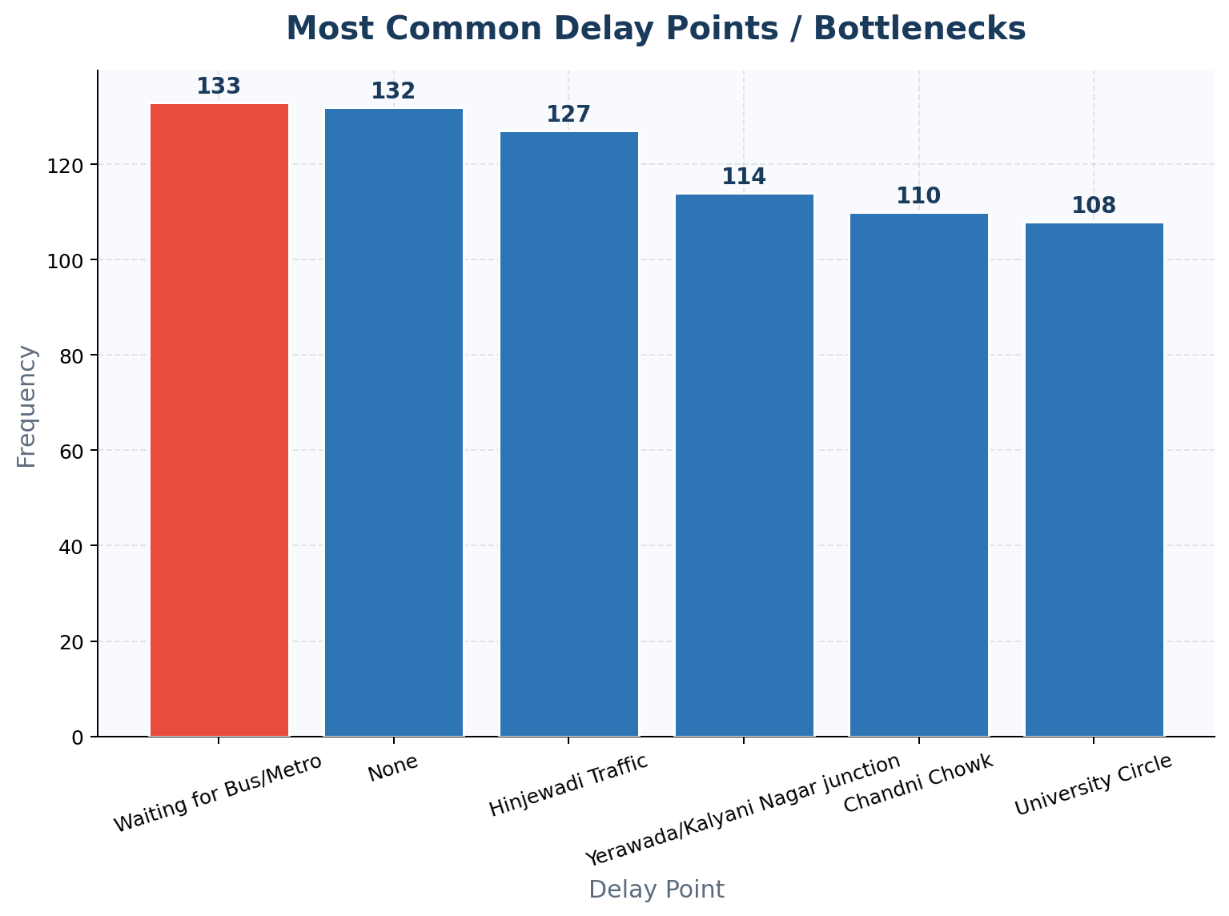
[Chart: Figure 4: Most Common Delay Points / Bottlenecks]

4.6 Comparative Analysis by Mode of Transport
Using groupby analysis, we computed the average travel time and cost for each mode of transport. These findings are represented in the horizontal bar charts below.
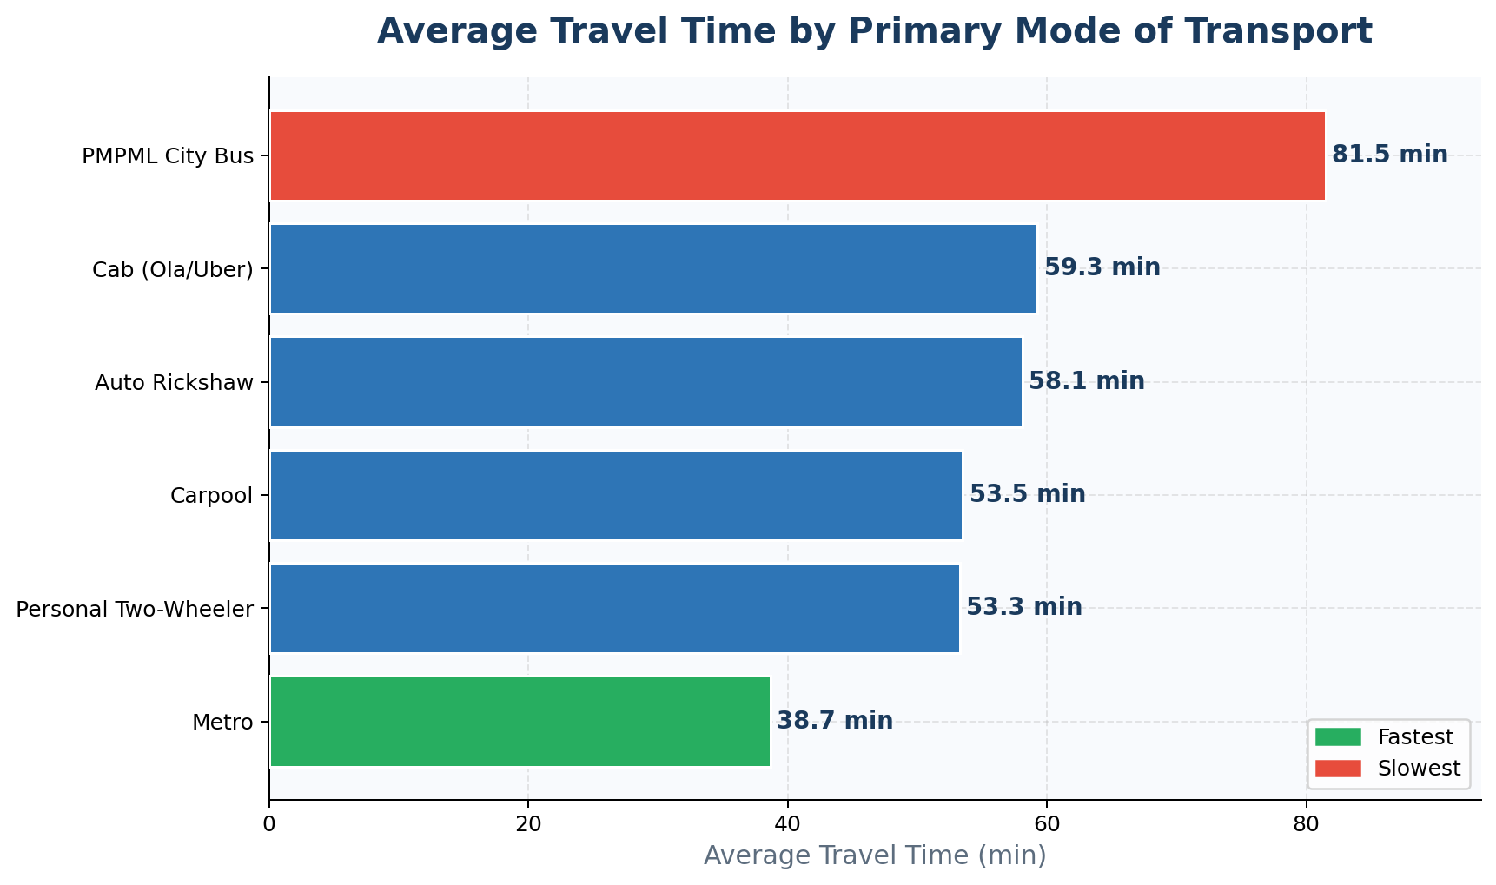
[Chart: Figure 5: Average Travel Time by Primary Mode]
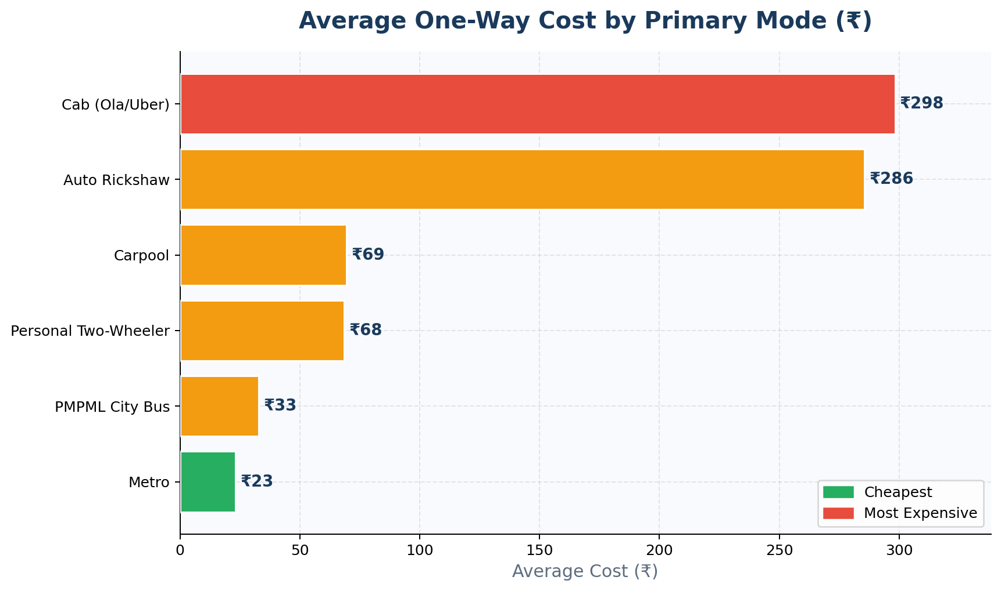
[Chart: Figure 6: Average One-Way Cost by Primary Mode]
The charts clearly show Metro as the dual winner — fastest and cheapest. Cab and Auto Rickshaw are the most expensive options. PMPML City Bus, while very affordable, is the slowest. Carpool and Personal Two-Wheeler offer a reasonable middle ground on both dimensions.

4.7 Satisfaction Analysis
Student satisfaction was measured on a 1–5 scale. The distribution is notably bimodal — scores of 1 (Very Low) and 5 (Very High) together account for over 45% of all responses, indicating that students have strongly polarised views about their commute.
- Score 1 (Very Low): 166 students (22.93%)
- Score 2 (Low): 139 students (19.20%)
- Score 3 (Neutral): 126 students (17.40%)
- Score 4 (High): 128 students (17.68%)
- Score 5 (Very High): 165 students (22.79%)

The near-equal distribution across all five scores (mean: 2.98) suggests that commute quality is subjective and varies widely based on route, mode, and personal expectations.

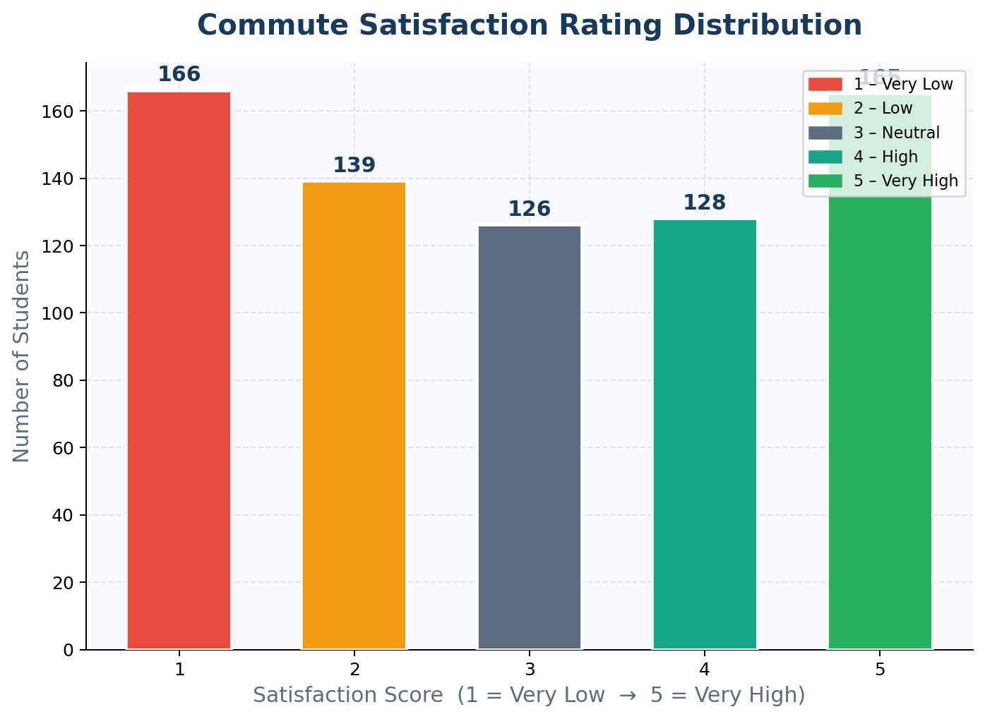
[Chart: Figure 7: Satisfaction Rating Distribution]

4.8 Commute Category Analysis (Derived Column)
A derived column 'Commute_Category' was created using the apply() function, classifying each trip as Short (<=30 min), Medium (31-60 min), or Long (>60 min).

Category | Criteria | Count | %
Short | <= 30 min | 109 | 15.06%
Medium | 31-60 min | 317 | 43.78%
Long | > 60 min | 298 | 41.16%

An overwhelming 84.94% of students commute for more than 30 minutes one way — highlighting that long commutes are the norm rather than the exception for students in Pune.

5. Key Findings Summary
The following table summarises the most significant findings from the EDA:

Finding | Detail
Total Survey Responses | 724 students
Most Used Primary Mode | Metro (131 students, 18.09%)
Least Used Primary Mode | Personal Two-Wheeler (98 students, 13.54%)
Fastest Mode on Average | Metro (~38.68 min avg)
Slowest Mode on Average | PMPML City Bus (~81.47 min avg)
Cheapest Mode on Average | Metro (~Rs. 23 avg)
Most Expensive Mode on Average | Cab/Ola/Uber (~Rs. 298 avg)
Average Travel Time | 57.47 minutes
Average One-Way Cost | Rs. 127
Most Common Starting Point | Kothrud (129 students)
Most Common Destination | Swargate & Viman Nagar (131 each)
Biggest Bottleneck | Waiting for Bus/Metro (133 cases)
Peak Commute Time Slot | Midday 11AM-4PM (205 commutes, 28.31%)
Most Common Satisfaction Score | Score 1 – Very Low (166 students)
Short Commutes (<=30 min) | 109 students (15.06%)
Long Commutes (>60 min) | 298 students (41.16%)
Missing Values Handled | 132 nulls in Delay_Points — filled with 'None'

6. Conclusion
This project successfully demonstrates the application of Exploratory Data Analysis on a real-world student commute dataset. By systematically applying twelve EDA techniques — ranging from basic inspection and descriptive statistics to cross tabulation, groupby analysis, and data visualisation — we were able to extract meaningful and actionable insights from 724 student responses.

The study confirms that Metro stands out as the most efficient mode of transport for students in Pune — it is simultaneously the fastest and most affordable. Cab services, while convenient, impose a significant financial burden. The widespread occurrence of long commutes (over 41% of students travel more than 60 minutes one-way) highlights a genuine quality-of-life concern for the student community.

The bimodal satisfaction distribution — with high concentrations at both Score 1 and Score 5 — suggests that commute experience is highly polarised. Students who use efficient modes like Metro tend to rate their experience positively, while those dependent on buses or cabs with high wait times report lower satisfaction.

This project reinforced our understanding of EDA as a powerful tool for uncovering patterns and stories hidden within raw data. The skills and techniques practised in this project — pandas operations, matplotlib visualisations, frequency analysis, and cross tabulation — form the foundational toolkit for any future data science work.

7. Future Scope
The following extensions could enhance this project in future semesters:
- Machine Learning: Build a predictive model to estimate commute satisfaction or travel time based on mode, route, and time slot
- Geospatial Analysis: Plot commute routes on a Pune city map using Folium or GeoPandas to visualise high-density corridors
- Time-Series Analysis: Collect data over multiple months to identify seasonal trends and semester-specific commute patterns
- Comparative Study: Compare commute data across different cities or different colleges to benchmark Pune against other urban student populations
- Recommendation System: Suggest the most optimal mode of transport for a given source-destination pair based on time and cost preferences

8. References
- Pandas Documentation — https://pandas.pydata.org/docs/
- Matplotlib Documentation — https://matplotlib.org/stable/contents.html
- NumPy Documentation — https://numpy.org/doc/
- Python 3 Official Documentation — https://docs.python.org/3/
- Seaborn Documentation — https://seaborn.pydata.org/
- McKinney, W. (2017). Python for Data Analysis (2nd ed.). O'Reilly Media.
- GitHub Repository: EDA-MiniProject-A3_Group1 —
(i) https://github.com/theTanmayAgarwal/EDA-MiniProject-A3_Group1
(ii) https://github.com/tanishthagupta-wq/EDA-MiniProject-A3_Group1

— End of Report —

